CLEANROOM KNOWLEDGE

- ESD (Electrostatic Discharge) - Definition

ESD is an abbreviation for Electrostatic Discharge. It is the sudden movement of electrons between two objects at different electrical potentials. This term is usually used in the electronics and other industries to describe momentary unwanted currents that may cause damage for electronic equipment. One of the factors that cause ESD events is static electricity. Static electricity is often generated when there are two materials are brought into contact and the electric charges are separated after the contact. Examples include walking on a carpet, descending from a car, especially in cold weather or removing certain types of plastic packaging

- Electrostatic Discharge (ESD) Test

Equipment and Monitoring Devices
Testing and verifying ESD devices are playing very crucial part to ensure that activity conduct by us is according to the procedure.
- Surface Resistance/Resistivity Meter
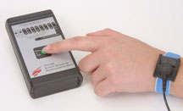

This Resistivity Meter is a wide range, multi-scale, auto-ranging meter. It measures resistivity in ohm/square (ASTM D257 units), resistance in ohms (ANSI/ESD S11.11 UNITS) and resistance to ground (RTG) for mats. This Resistivity Meter is suitable for auditing static control items. It measures conductive, dissipative and insulative items. The meter is based on battery powered and it is simple to use.

- Electrostatic Field Meter
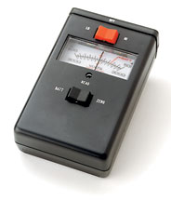
The function of Electrostatic Field Meter is to locate static charge before it can damage sensitive devices. This hand-held non-contact field meter finds static charge by measuring the field included materials, machines, and people. The measurement range are 0-30,000 volts.
- Wrist Strap Checker
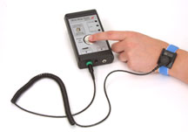
The Wrist Strap Checker verifies the proper operation of a wrist strap while a person wears it. The three segment display provides pass/fail indication. An audible tone will warns when there are of failures. This pocket-sized meter is cost effective. Testers are useful for checking grounding products designed to control static electricity for the protection of electronics. The Tester is powered by a 9 volt battery.

- Constant Wrist Strap Monitor
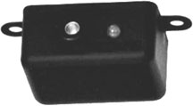
Constant Wrist Strap Monitor uses a solid state impedance design to continuously test the connection integrity of the entire ground loop including the person, the wrist band, and the coil cord. The constant monitor system is fully automatic and it can be activates when a wrist strap is plugged into the unit. When there is safe condition it will display green light and red light is for unsafe condition.
Prepared by: Menaga
Verified by: Georginia
Date: 02/03/2009

